Using the Clutter Image Rating Scale (CIR)

The Clutter Image Rating Scale consist of three sets of 9 colour photographs. Each set depicts a room in the home (living room, bedroom, and kitchen) with varying amounts of clutter (1=least cluttered, 9=most cluttered).

****Please enter the number of the image that best reflects the environment. It does not have to be an exact match, but what you feel is the nearest representation to your living environment

Room | Number of closest corresponding picture | Comments
Living Room

Kitchen

Bedroom 1

Bedroom 2

Bedroom 3

Please also rate the other rooms in your house as best as possible

Room | Number of closest corresponding picture | Comments
Dining Room

Garage

Hallway

Car

Shed

Loft / Attic

Other Room ( please state)

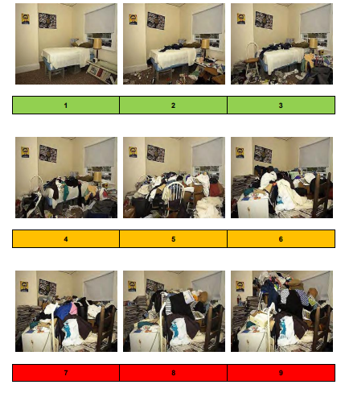
Clutter Image Rating Scale (CIR) – Bedroom

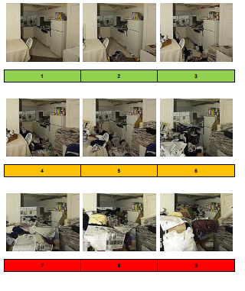
Clutter Image Rating Scale (CIR) – Kitchen

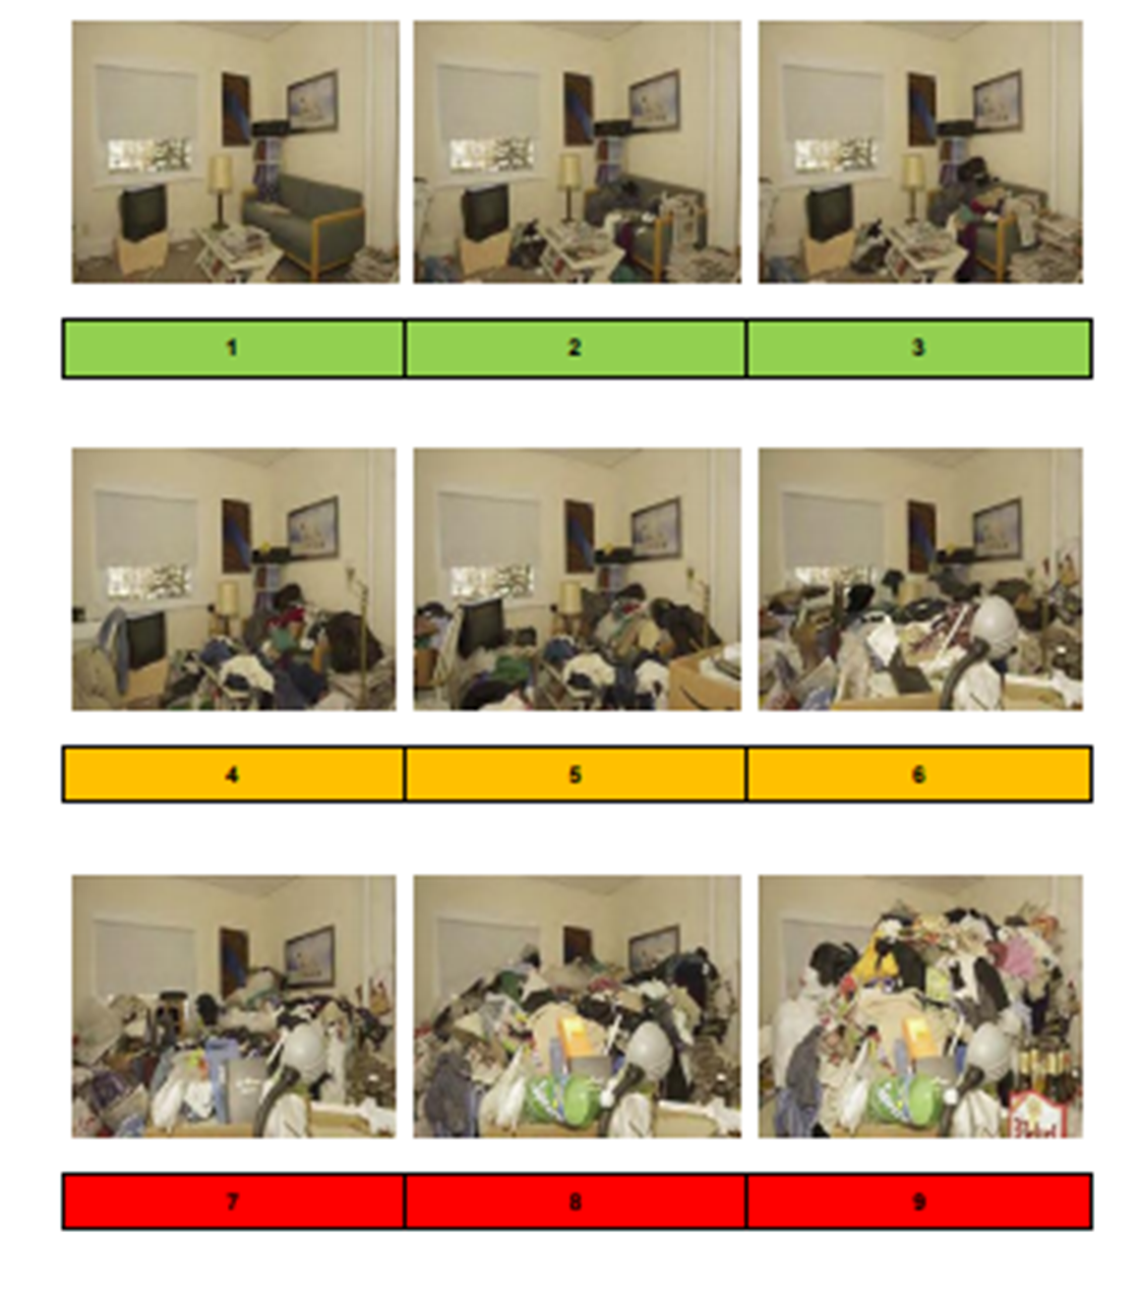
Clutter Image Rating Scale (CIR) – Living Room

